Meadows at Topsfield 2019 Budget

**HEADLINE**

* 2019 Budget $135,976
* 2019 Interior unit fee/month $455.00
* 2019 Exterior unit fee/month $490.00
* Effective Date: January 1, 2019

**EXECUTIVE SUMMARY**

|  |
| --- |
| * The 2019 Budget reflects an enhanced landscaping program (detailed below), an allowance for excess snow removal, increased spending for repairs, maintenance and gutter cleaning, allowance for replacement of golf nets and increased funding of the Reserve Fund. * The 2019 Budget represents a $35,608 or ~35% increase over the 2018 Budget and a $3,122 reduction against the 2018 Actual spending resulting in the monthly fees above. |
| * 16% or $16,176 of the increase relates to items that will not recur in the future - selected landscaping detailed below, repayment to the reserve fund for the Tree Plan and computer hardware/software for Association accounting. |
| * The Proposed 2020 Budget (not approved) is shown for discussion purposes. The table is presented as if the non-recurring "one-time" costs mentioned above were “redeployed” to increase reserve funding levels while keeping overall fees in line with 2019. More details below. |
|  |



**PROCESS**

The Board worked together to:

* Align on a Mission Statement for the Homeowner Association Board of Trustees
* Agree on the Guiding Principles that govern the interactions of Board members on association-related matters.
* Detail priority spending requirements for our community that were assessed across the dimensions of safety, functionality, aesthetics, investment and administration. They were also evaluated in terms of Importance and Urgency.
* Align on an overall level of spending that we think is reasonable to fulfill the fiduciary responsibility of the Board while providing for an extraordinary living experience
* Finally, we allocated resources to the spending priorities to arrive at the final 2019 Budget.

**DETAILS**

Landscaping and Tree Service

* Increased spending for landscaping reflects an enhanced level of contracted landscaping services with a new landscaping provider ($29,849) as well as one-time spending ($6,166) for investment projects.
* See attached Appendix A for landscaping contract details

Snow Removal

* Increased spending for snow removal includes baseline spending ($21,412) reflecting historical experience as well as $2,500 for snowfall in excess of historical amounts.

Insurance

* Spending is generally in line with previous periods.
* The Board conducted an Insurance Policy Review with our broker – WT Phelan. The Board is evaluating broker recommendations which will be the subject of a future Board meeting.
* See attached Appendix B for insurance policy details.

Repairs, Maintenance and Gutter Cleaning

* Increased spending for repairs and maintenance reflects enhanced focus on rain gutters to avoid a repeat of ice damming and an on-going program to maintain siding.

Golf Net Replacement

* Increased spending reflects replacement/repair of the golf net near hole #1 nearest the club house.

Reserve – Summary based on Reserve Study

* In 2018, the Association budget included $10,037 to fund the Reserve. This was calculated as 10% of the operating budget. This equates to ~20% of “full funding” as defined in the Reserve Study.
* In 2019, $13,547 is budgeted for reserves. ~27% of “full funding”. An increase reflecting a fiduciary responsibility to ensure funds will be available to address matters detailed in the Reserve Study.
* As mentioned above, the proposed 2020 budget anticipates the use of non-recurring “one-time” costs of 2019 ($16,176 – see details above) to increase funding of the Reserve Fund. This level of funding would result in ~60% of “full funding”.
* We will discuss the impact of these funding levels on our monthly fee and the impact that reserve funding levels might have on future assessments, if any. The table below is meant to be a frame of reference for further discussion during our January meeting. It is based on the Reserve Study and the assumptions therein.

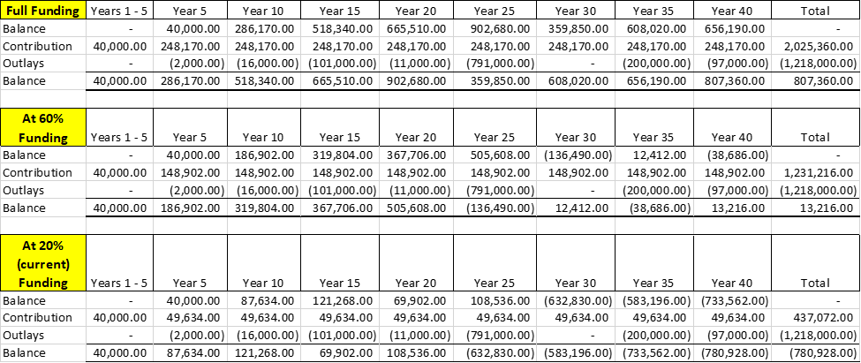

**ATTACHMENTS**

Attachment A



Attachment B

