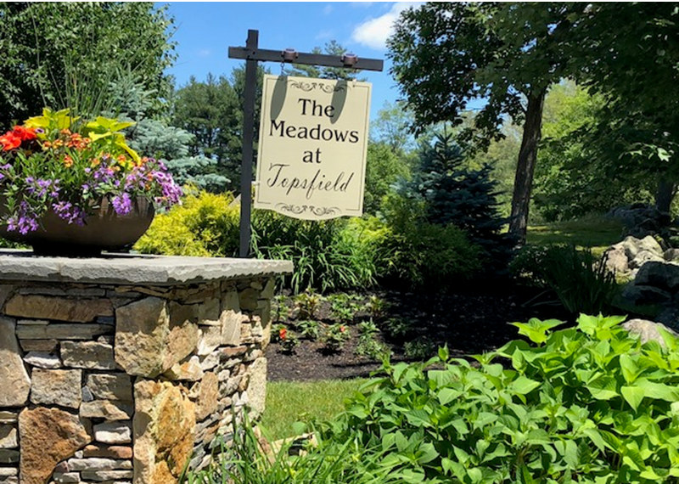

The Meadows at Topsfield Quarterly Newsletter – Issue #1

September 2018

# COMMUNITY NEWS

***Welcome to the Neighborhood***

Unit #2: Kathy and Steve Walsh

Kathy and Steve joined our community August 1.

Unit #7: Carol, Gregg and Cole Sampson

Carol, Gregg and Cole joined our community September 1.

***Thank You***

Unit #20: Many thanks to Bill Power who spent a lot of time researching quotes for snow removals.

## COMMUNITY Projects – WHAT’S GOING ON

***Community Meeting***: As promised our bi-annual meeting is scheduled for October 29 at the Library. Agenda items identified at this time will be By-laws and Budget status updates. If anyone wishes to discuss other topics – please let us know and we can add to the agenda accordingly – time permitting.

***BY-LAWS***: The Community meeting scheduled for October 29 will present information regarding the Community request for 6 By-Law changes. New facts regarding Town and State 2-bedroom restrictions for “Elder Housing” will also be explained in detail at that time.

***Trees***: The project to replace the trees along Fairway Drive started August 23rd. We will be able to use our well water to irrigate the trees.

***Landscape/Snow Removal***: Our new Landscape contractor is Schulte Incorporated who will be in charge of both our landscaping and snow removal needs. By combining these two contracts we anticipate potential yearly savings. We would like to remind the community that patience may be required for the short term until Schulte Inc. can thoroughly understand our needs and expectations.

***Approved Landscape Plantings***: The Great Hill Community has what we thought to be a “good idea” - providing a documented pre-selection of plantings (annuals and perennials) for neighbors to choose from if they wish to add to their planting beds. We are currently working with our landscaper to provide some 40 or so selections that would complement the neighborhood and not require any kind of Trustee approvals. Once complete – we’d love feedback on the selections and concept.

***Resurrection of the Meadows at Topsfield Website***: Thanks to Lucy Power who has graciously volunteered to maintain our Neighborhood Website. When done we will send out the link to the community for feedback regarding additional information you would like to see to additionally enhance our communications site. Planned so far are more “Human Interest” topics such as Upcoming Events, Living Vicariously via others’ Travels, Welcome to the World updates, etc.

***Voles***: For those of you who have noticed small black boxes here and there throughout the neighborhood, they are traps for pesky voles that have been chewing up some of the grass and landscape throughout the development. A vole is a small rodent, a relative of the mouse. Some of the signs they have been busy near your home are railroad track designs of dead grass or exposed dirt in your lawns. Should that be the case, please feel free to contact us and we’ll do what we can to address the issue.

***Siding/Handy Man***: Planned for this fall, CS Builders LLC from Ipswich has been hired to do our siding repairs. Buildings 1-5 will be addressed (building 6 is damage-free). The starting date will be communicated when finalized. CS Builders would/could be available should unit owners wish to enquire about other services.

***Bees***: Quite a few nests have been spotted around the neighborhood. Should you need help with removals, Tim and Richie have been taking care of that. Please reach out to Tim or Su and one of us will see that it gets addressed.

***Septic***: Our septic systems are scheduled to be checked this fall. Should it be determined they need to be serviced, pumping will be scheduled to take place before the end of the year.

## Financials

***OPERATING ACCOUNT***:

     Beginning Balance:  **June 1, 2018:** $11,058.28

     Deposits: $46,465

          HOA Dues:  $25,085

          Assessments: $21,380

          Payments: $42,407.54

Transfer to Reserve Account: $2,500

     Ending Balance: **August 31, 2018:** $12,615.74

***RESERVE ACCOUNT:***

     Beginning Balance: **June 1, 2018:** $50,878.08

     Transfer into Reserve Account: $2,500

Ending Balance: **August 31, 2018:** $53,378.08